**How to host Django Application using gunicorn & nginx in Production**

Django is a very powerful web framework and ships with a server which is able to facilitate development. This development server is not scalable and is not suited for production. Hence we need to configure gunicorn to get better scalability and nginx can be used as a reverse proxy and as a web server to serve static files.

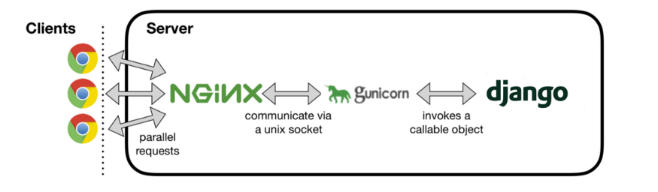

## **Step 1 - Installing python and nginx**

sudo apt update

sudo apt install python3-pip python3-dev nginx

## **Step 2 - Creating a python virtual environment**

sudo pip3 install virtualenv

mkdir ~/projectdir

cd ~/projectdir

virtualenv env

source env/bin/activate

## **Step 3 - Installing Django and gunicorn**

pip install django gunicorn

## **Step 4 - Setting up our Django project**

sudo apt update

cd textutils

ls

vim settings.py

[Add your IP address or domain to the ALLOWED_HOSTS variable in settings.py]

~/projectdir/manage.py makemigrations

~/projectdir/manage.py migrate

sudo ufw allow 8000

~/projectdir/manage.py runserver 0.0.0.0:8000

## **Step 5 - Configuring gunicorn**

gunicorn --bind 0.0.0.0:8000 textutils.wsgi

Visiting http://<ip-address>:8000 shows a page